Sales Data Analysis Project

CodeOrbit Tech — Data Analyst Internship | 1-Month Internship
Prepared by: Bhavana M
Project type: Sample sales data analysis using Python (pandas), Excel, and dashboard visualizations.
1. Abstract
This project demonstrates a basic end-to-end data analysis workflow using an illustrative retail sales dataset. The workflow includes data cleaning, exploratory analysis, calculation of key business metrics, grouping sales by product/category/region/month, and presentation of results in a dashboard.

2. Objective
- Identify and correct common data quality issues.
- Calculate total sales, order count, and average order value.
- Compare sales across products, categories, regions, channels, and months.
- Present findings and practical recommendations in a concise dashboard and report.

3. Dataset Description
The dataset is a synthetic sample created for demonstration, with 25 raw rows and fields for order ID, date, region, category, product, unit price, quantity, and channel. It is not actual CodeOrbit Tech or real business data.

4. Data Cleaning Process
- Trimmed extra spaces from text fields and standardized capitalization for region, category, product, and channel.
- Converted unit price and quantity to numeric data types and parsed order dates.
- Filled the missing product label with 'Unknown' to preserve the record.
- Filled one missing quantity with 1 as an explicit demonstration assumption; in a real project this should be confirmed with the data owner.
- Removed 1 duplicate business record(s), keeping the first occurrence.
- Created a Sales field using Unit_Price × Quantity and a Month field from Order_Date.
5. Key Performance Indicators
Metric | Result
Total sales | ₹1,620.00
Unique orders | 24
Average order value (total sales ÷ unique orders) | ₹67.50
Top product by sales | Headphones (₹300.00)
Top region by sales | South (₹472.00)
Top category by sales | Electronics (₹800.00)
Duplicate business records removed | 1
6. Findings
The highest-sales product in this sample is Headphones, contributing ₹300.00.
The strongest region by sales is South, with ₹472.00.
The leading category by sales is Electronics, with ₹800.00.
The highest-sales month in this sample is 2026-03 (₹693.00).

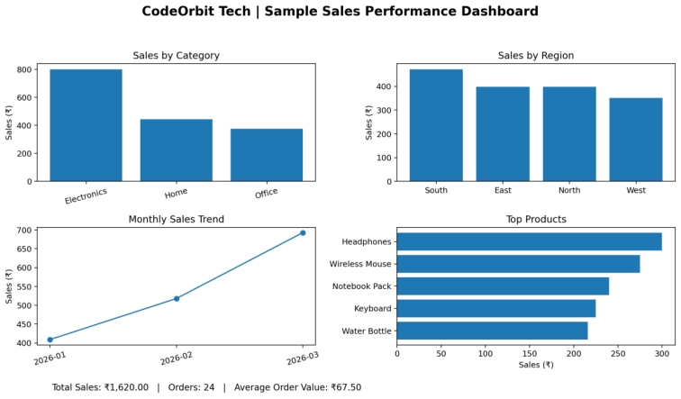

7. Recommendations
- Review inventory and product availability for Headphones, the highest-sales product in this sample.
- Investigate what drives performance in the South region and test whether successful practices can be replicated elsewhere.
- Track monthly sales consistently and compare trends over a longer period before making major decisions.
- Improve data entry validation for dates, quantities, regions, and product names.
- Confirm missing-value assumptions with a business owner before applying them to production data.

8. Limitations
The dataset is small and synthetic. Results are suitable for demonstrating methods, not for making real business decisions. One missing quantity was imputed as 1 only as a documented example; a real analysis should validate this assumption.

9. Conclusion
The project demonstrates a reproducible workflow for cleaning sales data, calculating KPIs, identifying sales patterns, and communicating results. The same approach can be applied to a larger verified dataset.

